

Vim

Presented by

Prangchompoo Sombat 6607012660078

Presented to
ASSISTANT PROFESSOR DR. NATTAPORN UTAKRIT
Fundamental Computer and Networking (070153603)

Program in Informatics for Digital Economy Faculty of Information Technology Innovation

What is Vim?

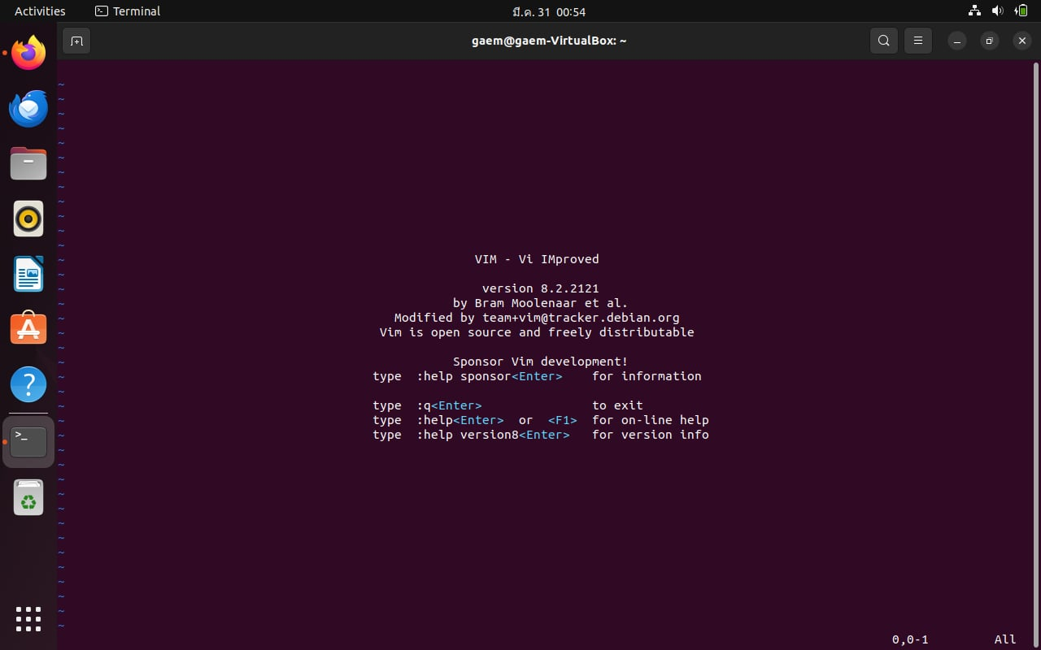

Vim is a text editor for Unix that comes with Linux, BSD, and macOS. It is known to be fast and powerful, partly because it is a small program that can run in a terminal (although it has a graphical interface). It is mainly because it can be managed entirely without menus or a mouse with a keyboard.
Why install Vim?
Vim is a powerful text editor popular among developers. It's based on shortcuts, called the Vim language, which can make coding and writing faster and more efficient.

How to install Vim

Step 1: Open terminal application.
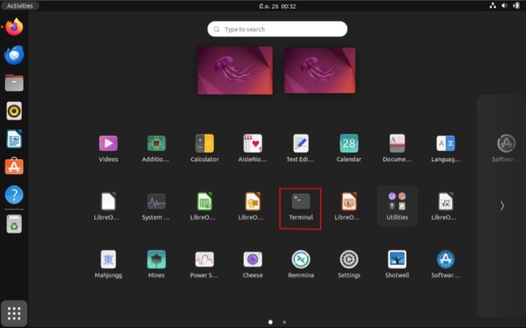

Step 2: Update the package list “ sudo apt update”
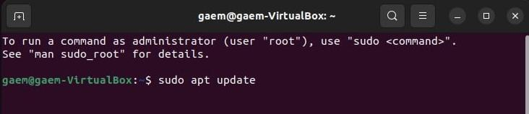
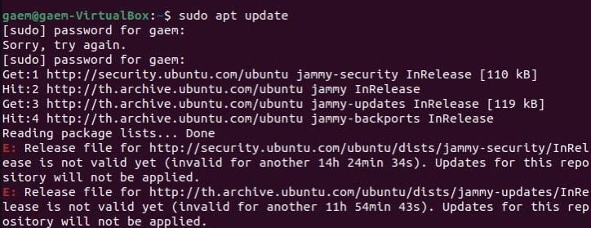

Step3: Install Vim “sudo apt install vim -y”
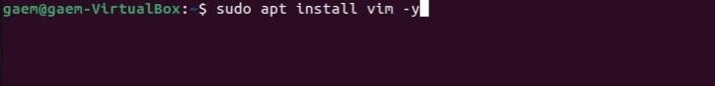
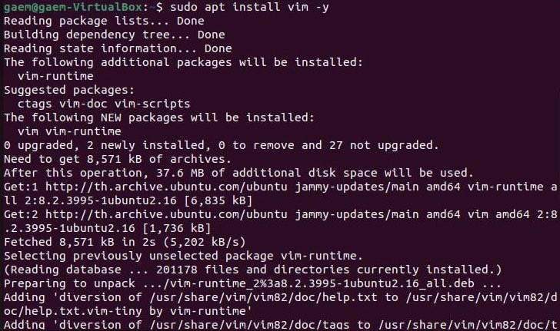
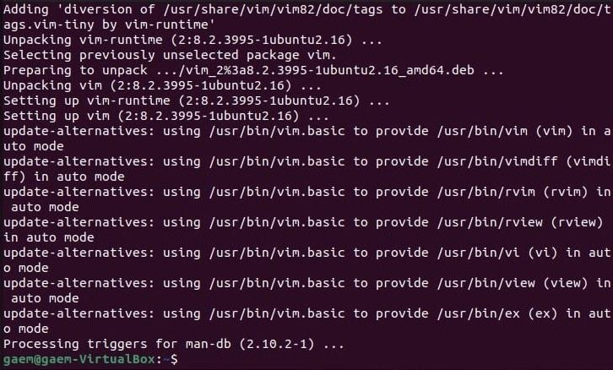

Step4: Verify the installation “vim --version”
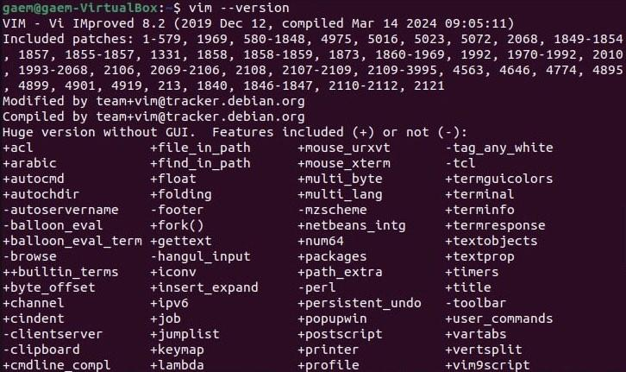
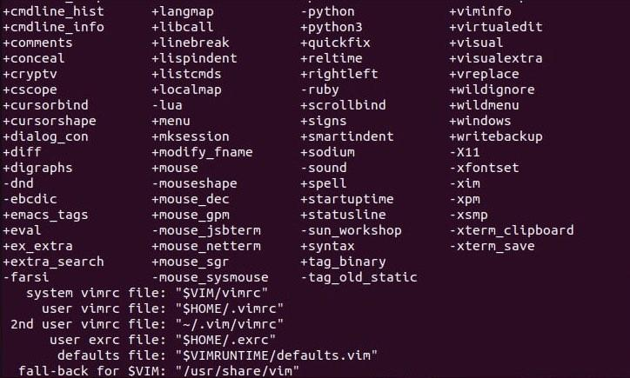

An Example Project
- I use Vim to write keystrokes for vim users. For Beginners to learn the basics of using Vim.
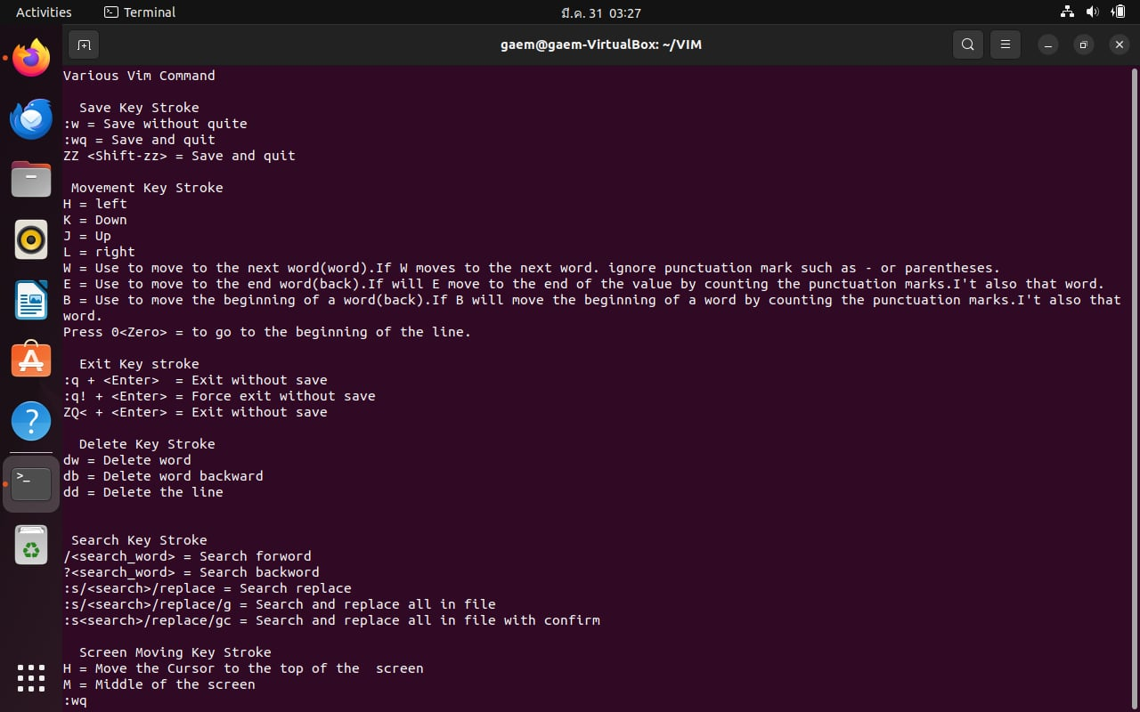
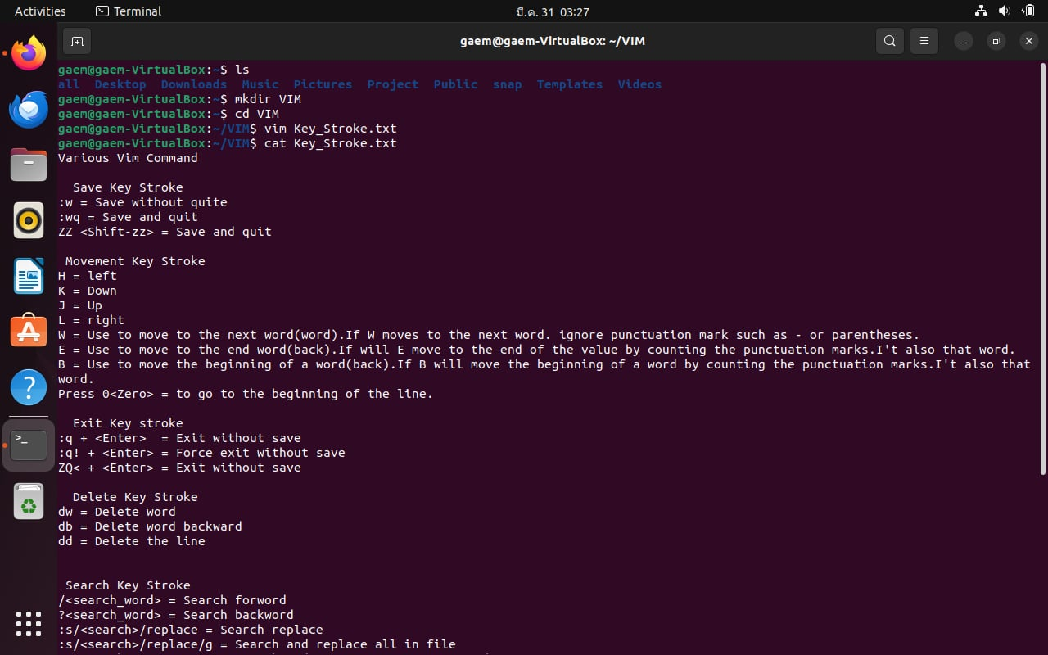
https://docs.google.com/document/d/1fh00sPe4xSr8coPvjyML8CxWFdx1754PBzHGj2xJ8Wo/edit?usp=sharing
References
https://www.cherryservers.com/blog/install-vim-ubuntu
https://www.loginradius.com/blog/engineering/vim-getting-started/
https://www.freecodecamp.org/news/vim-language-and-motions-explained/

